EFIT Assignment Applied Logic

Wed 27 Jan 2021, 10:30 - 12:00, R10

Teachers: Geurts, Andova

For all exercises:

* upload the smt file (i.e. the z3-input text file) with ***explanation of the clauses***
* upload the output file (this can also be a screen shot of the cmd-window)

Exercise 1

Spend exactly 400 euro and buy exactly 100 animals.

Dogs cost 60 euro, cats cost 4 euro, and mice cost 1 euro each.

You have to buy at least one of each.

How many of each should you buy?

BONUS: Is there another solution? If yes, what is it? If not, explain.   
(tip: use z3-clauses to find out, and remember week 1 (slide 12, question c): how you get the second roots of a quadratic equation)

Exercise 2

In this Zebra puzzle we have 3 Houses (1, 2, and 3). They are each colored differently (either pink, red or yellow). In each house lives a different animal (either a fish, a mouse or a zebra). And they each have a different drink (either tea, coffee or beer).

Use z3 to find out for each house: the color, the animal and the drink.

Present the results in a clear table.

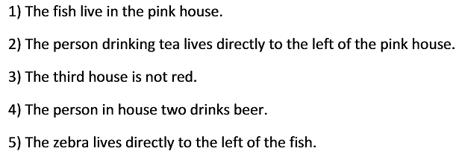

Exercise 3

Solve the self-referential quiz:

